TABLE OF CONTENTS

CANDIDATE DECLARATION | i
PROJECT GUIDE CERTIFICATE | ii
CERTIFICATE | iii
ACKNOWLEDGEMENT | iv
ABSTRACT | v
TABLE OF CONTENTS | vi
LIST OF FIGURES | vii
Chapter | Page No.
Chapter 1 –  INTRODUCTION | 1-3
1.1 Overview
1.2 Brief Description
1.3 Problem Definition
1.4 Applying Software Engineering Approach
Chapter 2 –  LITERATURE SURVEY | 4-5
2.1 Crime Reporting & Digital FIR Systems
2.2 Benefits of e-FIR Platforms
2.3 Role of Web Technologies in Law Enforcement
Chapter 3 –  SOFTWARE REQUIREMENTS SPECIFICATIONS | 6-14
3.1 Introduction
3.2 System Features
3.3 Performance Analysis
3.4 Hardware & Software Interfaces
3.5 Security & Compliance
3.6 Analysis Models
Chapter 4 –  SYSTEM DESIGN | 15-20
4.1 System Architecture
4.2 UML Diagrams
Chapter 5 –  TECHNICAL SPECIFICATIONS | 21-28
5.1 Technologies Used in Product
5.2 Coding Files
Chapter 6 –  SOFTWARE TESTING | 29-30
6.1 Introduction
6.2 Test Cases
Chapter 7 – RESULTS (SNAPSHOTS OF RESULTS) | 31
CONCLUSION | 32-33
REFERENCES | 34

LIST OF FIGURES

Figure No. |  | Page No
Fig 1.1 | Software Engineering Approach | 3
Fig 3.1 | Data Flow Diagram Level 0 | 13
Fig 3.2 | Data Flow Diagram Level 1 | 13
Fig 3.3 | Class Diagram | 14
Fig 3.4 | Entity Relationship Diagram | 14
Fig 4.1 | System Architecture | 17
Fig 4.2 | Use Case Diagram | 18
Fig 4.3 | Sequence Diagram | 19
Fig 4.4 | Activity Diagram | 19
Fig 4.5 | Component Diagram | 20
Fig 4.6 | Work Flow Diagram | 20

CHAPTER 1
INTRODUCTION

1.1 OVERVIEW
In today's digital world, the traditional paper-based crime reporting process is inefficient, time-consuming, and prone to errors. Citizens often face difficulties in registering complaints due to geographical constraints, long queues at police stations, and lack of transparency in case status. A web-based Crime Reporting System integrated with an Electronic First Information Report (e-FIR) management platform addresses these challenges by providing a digital interface for both citizens and law enforcement.

This project provides an end-to-end solution for crime reporting on a secure web portal. It covers everything from online complaint registration by citizens, case assignment to concerned officers, real-time status tracking, and digital FIR generation. By leveraging secure authentication, encrypted databases, and role-based access control, this project demonstrates how to efficiently deploy and manage a digital law enforcement platform.

Through this implementation, we aim to showcase the transparency, efficiency, and ease of management that an e-FIR system offers, making it a valuable solution for police departments and law enforcement agencies looking to modernize complaint management workflows.

1.2 BRIEF DESCRIPTION
This will describe the overall mathematical model of the project and the set theory used in the project.
1.2.1 Project Problem statement:
To build a scalable and efficient crime reporting and e-FIR management system, ensuring automated case tracking, seamless complaint management, and optimized routing of FIRs to appropriate law enforcement units.
1.2.2 Problem description:
- Complaint Registration and Management: Automating the creation and tracking of crime complaints to reduce manual overhead.
- FIR Generation and Assignment: Implementing a structured approach to generate and assign FIRs to concerned officers using digital workflows.
- Case Routing and Status Management: Ensuring reliable routing of cases to appropriate departments with real-time status updates for citizens.
- Scalability and Performance Optimization: Designing a system that can handle high volumes of complaint submissions while maintaining efficiency.
- Security and Monitoring: Integrating user authentication, role-based access control, and audit logging to ensure secure and observable operations.

1.3 PROBLEM DEFINITION
The goal of this project is to create an automated and scalable crime reporting and e-FIR management system, enabling efficient complaint handling, seamless status tracking, and optimized case assignment. By implementing role-based access control, digital FIR workflows, and secure database integrations, the project aims to simplify the complexities associated with traditional manual crime reporting operations.

1.4 APPLYING SOFTWARE ENGINEERING APPROACH
The incremental model is an evolution of the waterfall model. The product is designed, implemented, integrated, and tested as a series of incremental builds. It is a popular model of software evolution used by many commercial software companies and system vendors. An incremental software development model may apply to projects where Software Requirements are well defined, but realization may be delayed.

[Fig 1.1 - Software Engineering Approach Diagram]

Advantages:
- Provides working infrastructure early in the development lifecycle.
- More flexible and scalable to accommodate changes.
- Improved risk management by addressing deployment challenges incrementally.
- Better testing and debugging with modular implementation.
Disadvantages:
- Requires careful planning to ensure all components integrate seamlessly.
- Incremental updates might lead to architecture modifications over time.

CHAPTER 2
LITERATURE SURVEY

2.1 CRIME REPORTING AND DIGITAL FIR SYSTEMS
Digital crime reporting systems play a crucial role in modern law enforcement and public safety management. These platforms are designed to automate the registration, tracking, and management of criminal complaints, allowing law enforcement agencies to efficiently manage workloads across multiple jurisdictions. e-FIR systems enable complaints to be filed from anywhere and ensure that FIRs are generated, stored, and retrieved in a standardized digital format.

Traditional paper-based FIR systems face challenges related to accessibility, record maintenance, and retrieval speed. Digital FIR systems overcome these by providing automated workflows, electronic record keeping, and real-time communication between citizens and police. These platforms support features such as auto-assignment of cases, status notifications, and integrated evidence management, streamlining law enforcement operations while maintaining high accountability and performance.

By abstracting procedural complexities, digital platforms allow officers to focus on investigation rather than paperwork. e-FIR systems integrate well with modern law enforcement databases, making them an essential tool in public safety operations.

2.2 BENEFITS OF USING e-FIR PLATFORMS
Fully Digital Workflow:
e-FIR platforms eliminate the need for manual paperwork by digitizing the entire complaint registration and FIR generation process. Citizens can submit complaints online, and police officers can access and process them from anywhere.
Seamless Integration:
e-FIR systems integrate natively with national crime databases, court management systems, and identification systems, making it easy to cross-reference cases and track suspects across jurisdictions.
High Availability and Transparency:
e-FIR systems ensure citizens can track their complaint status at all times. The system supports real-time notifications and audit logs, minimizing procedural delays and ensuring all actions are recorded.
Security and Compliance:
e-FIR platforms implement security best practices, including data encryption, identity-based access, and automated audit trails. This ensures that complaint records remain secure while adhering to legal and compliance standards.

2.3 ROLE OF WEB TECHNOLOGIES IN LAW ENFORCEMENT
Modern web technologies enable law enforcement agencies to build scalable, accessible, and secure complaint management platforms. RESTful APIs allow seamless communication between the citizen portal and the backend police database. Role-based access control (RBAC) ensures that citizens, officers, and administrators only access the data relevant to their roles.

Key advantages of using modern web technologies include real-time status updates through WebSocket or polling mechanisms, cloud-based storage for complaint records, digital signature integration for FIR authentication, and mobile-responsive interfaces for accessibility from any device. By implementing these technologies, law enforcement agencies can simplify case management and improve public trust.

CHAPTER 3
SOFTWARE REQUIREMENTS SPECIFICATIONS

3.1 INTRODUCTION
This project aims to develop a comprehensive Crime Reporting and e-FIR Management System, enabling automated complaint registration, seamless FIR generation, and optimized case routing. By implementing secure authentication, role-based access control, and real-time tracking mechanisms, the project enhances the reliability and scalability of digital law enforcement workflows. The system's modular architecture makes it a perfect solution for deploying citizen-facing and officer-facing portals.
3.1.1 OBJECTIVE
Automating Crime Complaint Registration to Streamline Law Enforcement Workflows: One of the fundamental objectives of this project is to automate the process of registering crime complaints and generating FIRs. Traditional complaint management involves manual paperwork, which can be time-consuming and error-prone. By leveraging web technologies and database automation, this project aims to simplify and automate these tasks, allowing officers to process and assign cases with minimal effort. Automation ensures consistency across records, reducing the risk of misclassifications and enhancing processing efficiency.

Deploying a Citizen-Facing Portal with Optimized Case Tracking to Ensure Efficient Access and Communication: The project involves providing a real-time case status tracking application on a secure web portal. This cloud-native approach ensures portability, scalability, and reliability. One of the key challenges in managing complaints online is establishing efficient communication between different application components and external users.

Implementing Role-Based Access Control for Efficient External Access Management, Reducing Dependency on Multiple Login Systems: In a law enforcement environment, managing user access often requires different credential sets for citizens, officers, and admins. This project implements RBAC to consolidate access management, allowing multiple roles to share a single system while maintaining data isolation. The system intelligently routes access based on user roles, reducing infrastructure complexity and simplifying security management.

Ensuring Data Security and Audit Logging for Compliance and Monitoring: Data security and audit trails are critical aspects of any law enforcement application. The system integrates secure authentication using JWT tokens, encrypted data storage, and comprehensive audit logging. This project configures role-based permissions, data access policies, and security groups to enforce strict compliance standards.
3.1.2 PROJECT SCOPE
This project aims to provide an end-to-end Crime Reporting and e-FIR Management solution, focusing on automation, scalability, security, and efficient case management. The primary goal is to streamline the registration and management of crime complaints by eliminating the complexity associated with manual FIR processes. By leveraging modern web technologies like JWT authentication, React frontend, Node.js backend, and MongoDB database, the project ensures that complaints are managed in a highly available and secure environment.

Additionally, this project implements a real-time complaint tracking system as a use case to demonstrate the practical application of digital FIR management. It focuses on automating complaint registration, generating FIRs using digital workflows, and utilizing role-based access control for centralized user management. Security is a key consideration, with JWT-based authentication, RBAC policies, and monitoring solutions to ensure operational visibility. The project also emphasizes scalability through efficient database indexing and pagination for handling large volumes of complaints.
3.1.3 User Classes and Characteristics
Administrator
- Oversees the entire complaint management system, manages user accounts, and ensures high availability.
- Has full privileges to create, modify, and delete user accounts and case records.
- Monitors system performance and takes necessary actions in case of failures.
Police Officer
- Receives assigned complaints, processes FIRs, and updates case status.
- Uses the system to view evidence, update investigation notes, and manage case workflows.
- Works on case resolution and closure, updating final status for citizen notification.
Citizen
- Accesses the portal through a secure web-based UI.
- Performs tasks such as registering complaints, uploading evidence, and tracking case status.
- Receives real-time notifications on case updates and FIR generation.
3.1.4 OPERATING ENVIRONMENT
Web Application Server
The backend is built on Node.js with Express framework, providing a REST API layer for all client-server interactions. It integrates seamlessly with the MongoDB database, authentication systems, and notification services, allowing scalable and cost-efficient application hosting.
Database
MongoDB is used as the primary database. Instead of provisioning separate databases for each module, the complaint management system consolidates all data handling and retrieves records efficiently based on document queries. This reduces costs and simplifies data management.
3.1.5 PRODUCT FEATURES
Online Complaint Registration - Citizens can register complaints from anywhere without visiting a police station.
Digital FIR Generation - Automated FIR creation with digital document formatting and unique reference numbers.
Role-Based Access Control - Citizens, officers, and admins have separate access levels and dashboards.
Case Assignment and Tracking - Automated assignment of complaints to officers with real-time status updates.
Real-Time Notifications - Email and SMS notifications for complaint status updates and FIR generation.
Audit Logging Capabilities - Complete audit trail of all actions performed on the system.

3.2 SYSTEM FEATURES
The system is designed to provide a highly efficient, scalable, and secure Crime Reporting and e-FIR Management platform. The key features include:
Automated Complaint Registration
Complaint registration is automated using a web-based form with validation. Instead of manually processing paper complaints, the system automates the entire registration workflow, reducing errors and time. This ensures quick, repeatable, and efficient complaint processing for production environments.
Containerized Application Deployment
The system follows a microservices-based approach, where each module (complaint service, FIR service, user management, notifications) runs as an independent service. This ensures modular, scalable, and efficient workload management.
Role-Based External Access Management
To expose services to external users, the project implements role-based dashboards. Instead of provisioning individual portals for each role, access control consolidates external access and routes requests efficiently based on user roles and permissions, reducing infrastructure complexity.
Secure Authentication and RBAC
Security is a top priority. The system is configured with JWT-based authentication and RBAC to restrict unauthorized access. JWT ensures that only authorized users and officers can interact with the system, while RBAC limits data access based on predefined roles and permissions, ensuring a secure operating environment.
Comprehensive Audit Logging
To maintain observability and performance tracking, the system integrates comprehensive audit logging. All user actions, complaint submissions, FIR generations, and status updates are logged, helping in troubleshooting, optimizing resource utilization, and detecting anomalies.

3.3 PERFORMANCE ANALYSIS
To ensure high efficiency and optimal resource usage, the system undergoes continuous performance evaluation based on the following key metrics:
- Database Query Optimization
MongoDB Indexes are created on frequently queried fields such as complaint ID, citizen ID, and case status to minimize response times.
The system uses pagination and filtering to scale query results dynamically when complaint volumes are high.
- API Performance
All REST API endpoints are benchmarked to ensure responses are within acceptable response time thresholds.
Load testing tools like Apache JMeter are used to simulate real-world traffic scenarios, ensuring services remain responsive.
- Scaling Efficiency
The project evaluates horizontal scaling by adding more backend instances behind a load balancer.
Database sharding and replication ensure data availability and performance under high load.

3.4 HARDWARE & SOFTWARE INTERFACES
The system is designed to run in a web-based environment, requiring specific hardware and software components for optimal performance.
Hardware Interfaces
- Web Server: Minimum 4 vCPUs and 8GB RAM to ensure smooth execution of concurrent API requests.
- Database Server: MongoDB with minimum 8GB RAM and SSD storage for fast read/write complaint operations.
- Client Devices: Any modern browser-enabled device (desktop, mobile, tablet) for accessing the portals.
Software Interfaces
- Node.js with Express: The core backend framework providing REST API services.
- React.js: Frontend framework for the citizen and officer portals.
- MongoDB: Primary database for storing complaint records and FIR data.
- JWT Authentication: Used for secure user authentication and session management.
- Nodemailer / SMS Gateway: Integrated notification services for complaint status updates.

3.5 SECURITY & COMPLIANCE
Security is a critical aspect of the Crime Reporting System, ensuring that only authorized users and services can access case resources. The system enforces security best practices through the following mechanisms:
- Role-Based Access Control (RBAC) for Access Control: RBAC policies are implemented to ensure that only authorized users and applications have access to system resources. Service accounts are assigned minimal required privileges, reducing the risk of privilege escalation attacks.
- Data Encryption and Secure Storage: Sensitive data is encrypted both in transit (HTTPS/TLS) and at rest (AES-256). Secure cloud storage with proper access policies is used for storing critical complaint files and evidence.
- Security Audits and Log Analysis: System logs all API actions with timestamps, enabling auditing and tracking of security events. Alerts help detect anomalies, unauthorized access attempts, and potential security breaches. Regular vulnerability assessments are conducted to identify and fix security weaknesses.

3.6 ANALYSIS MODELS
3.6.1 DATA FLOW DIAGRAM
Level 0: The top-level DFD shows three external entities: Citizens who submit complaints, Law Enforcement Officers who process FIRs, and the Admin who manages the system. All interact with the central System, which produces outputs including complaint acknowledgements, FIR documents, and status notifications.

[Fig 3.1 - Data Flow Diagram Level 0]

Level 1: Expands into sub-processes: Complaint Registration Sub-process, FIR Generation Sub-process, Case Assignment Sub-process, Status Tracking Sub-process, and Notification Management Sub-process.

[Fig 3.2 - Data Flow Diagram Level 1]
3.6.2 CLASS DIAGRAM
The class diagram shows software components: User, Complaint, FIR, Officer, CaseAssignment, Evidence, and NotificationHandler with their respective attributes and methods.

[Fig 3.3 - Class Diagram]
3.6.3 ENTITY RELATIONSHIP DIAGRAM
The ER diagram illustrates entity relationships: Citizen (citizenID, email, phone) linked to Complaint (complaintID, description, status), which is linked to FIR (firID, dateGenerated) and Officer (officerID, badge, department), with Evidence (evidenceID, fileType) attached to complaints.

[Fig 3.4 - Entity Relationship Diagram]

CHAPTER 4
SYSTEM DESIGN
Design is the fundamental stage in developing a Crime Reporting and e-FIR Management System, focusing on identifying software components, defining their interactions, and structuring them for efficient deployment. In this project, the Node.js and React.js stack is used to orchestrate the web application, ensuring high availability and scalability. The system architecture follows a modular approach, dividing the workload into separate services that interact through RESTful APIs. This modularity minimizes dependencies between components and enhances maintainability while ensuring seamless integration with authentication, notification, and database services.

The implementation phase converts the theoretical design into a working system, involving the setup of the backend server, deployment of the complaint management modules, and configuration of security policies. This stage is critical to ensuring successful deployment and operational efficiency. It includes provisioning the Node.js backend, defining REST API routes, setting up the React frontend, configuring JWT-based access control, and setting up MongoDB collections with proper indexing.
EXPECTED INPUT
Input design refers to the process of defining how citizen and officer requests and system configurations are processed. The primary inputs include:
Complaint Registration Inputs:
- Citizen personal details (name, contact, address).
- Crime description, date, location, and category.
- Evidence uploads (images, documents).
FIR Generation Inputs:
- Verified complaint data reviewed by the system.
- Assigned officer details and jurisdiction information.
Security Inputs:
- JWT tokens for access control and user authentication.
- Network policies defining data flow between services.
EXPECTED OUTPUT
Output design refers to the results and data generated by the system, ensuring it delivers useful insights and application functionality. The expected outputs include:
- Application-Level Outputs: Real-time complaint acknowledgements, FIR copies (PDF format), and status notifications to citizens via email/SMS.
- Cluster & Infrastructure Outputs: Server logs and events that track application behavior, performance metrics providing CPU and memory utilization insights.
- Security & Monitoring Outputs: Audit logs indicating all user access and actions, alerts and dashboards displaying real-time system health and performance.

4.1 SYSTEM ARCHITECTURE
The system architecture consists of the following layers: Frontend Layer (React.js - Citizen Portal and Officer Dashboard), API Gateway Layer (Node.js Express REST API), Authentication Layer (JWT Token Management), Business Logic Layer (Complaint Service, FIR Service, Notification Service), Data Layer (MongoDB - Complaints, Users, FIRs, Evidence), and Security Layer (RBAC, Input Validation, Audit Logging).
The system follows a three-tier client-server architecture. The client-side is the user interface where citizens, officers, and admins interact with the system. The server handles processing and business logic. The database stores all FIR records, user accounts, and case data.

Data Flow Diagram / System Flow
- The citizen registers, logs in, and files an FIR with all relevant incident details.
- The admin reviews the submitted FIR and assigns it to the appropriate police officer.
- The police officer updates the case status as it progresses through investigation.
- The citizen tracks the FIR status through their dashboard until the case is resolved.

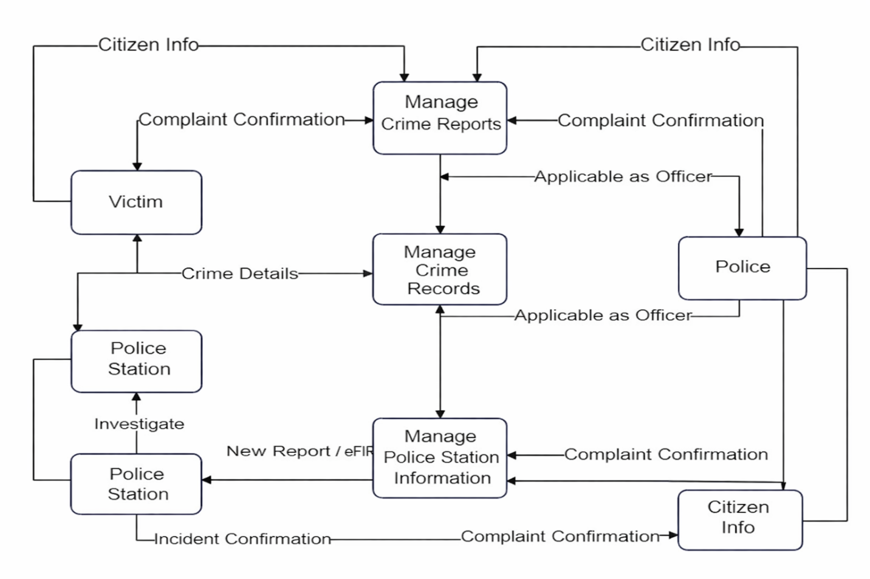
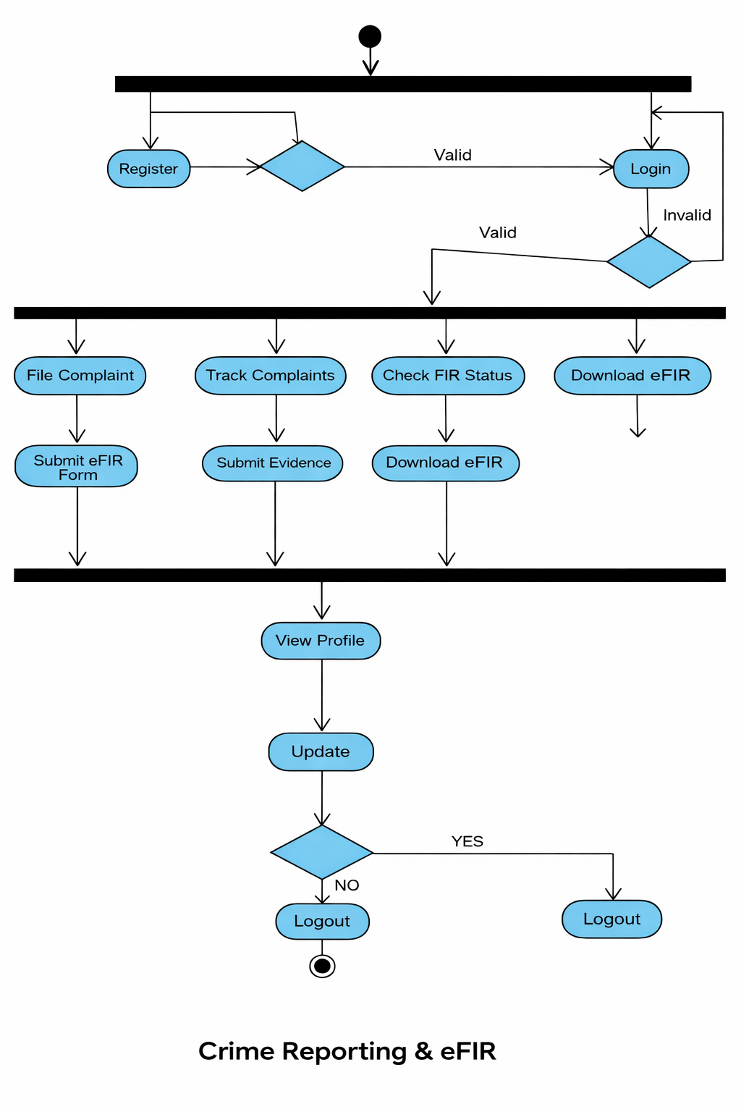

4.2 ER Diagram
Here is an ER (Entity-Relationship) Diagram description for the Crime Reporting and E-FIR System that captures the main entities and their relationships. The entities involved include: Users (Citizens/Officers), FIR, Crime, Police Station, and Officer.

Entities and Relationships:

1. User
- Attributes: UserID, Name, Email, Password, Phone, UserType (Citizen/Officer/Admin)
- Relationships: A User (Citizen) can file multiple FIRs. A User (Officer) can be assigned multiple FIRs.

2. FIR
- Attributes: FIRID, CrimeType, IncidentDate, IncidentLocation, Description, SuspectDetails, CitizenID (FK), OfficerID (FK), Status (Pending, Under Investigation, Resolved, Closed)
- Relationships: An FIR is filed by one Citizen and assigned to one Officer. An FIR is linked to one Police Station.

3. Police Station
- Attributes: StationID, StationName, Jurisdiction, Address, Contact
- Relationships: A Police Station handles multiple FIRs and employs multiple Officers.

4. Officer
- Attributes: OfficerID, Name, BadgeNumber, Rank, StationID (FK)
- Relationships: An Officer is assigned to one Police Station and handles multiple FIRs.

ER Diagram (Textual Representation):
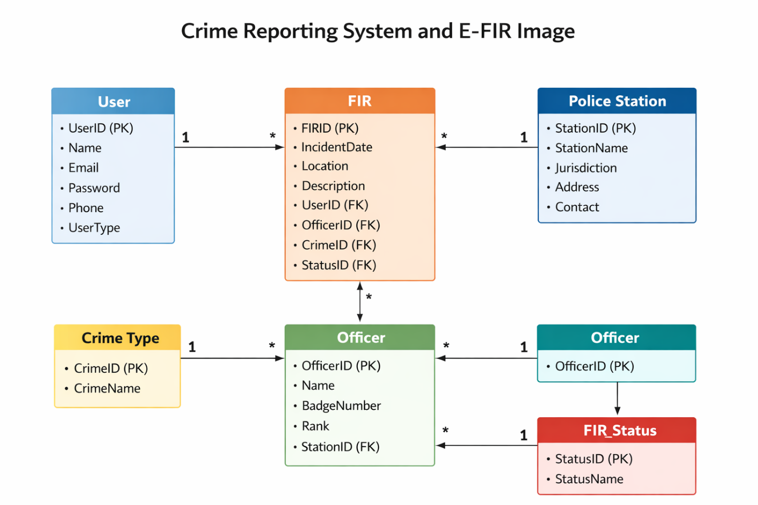

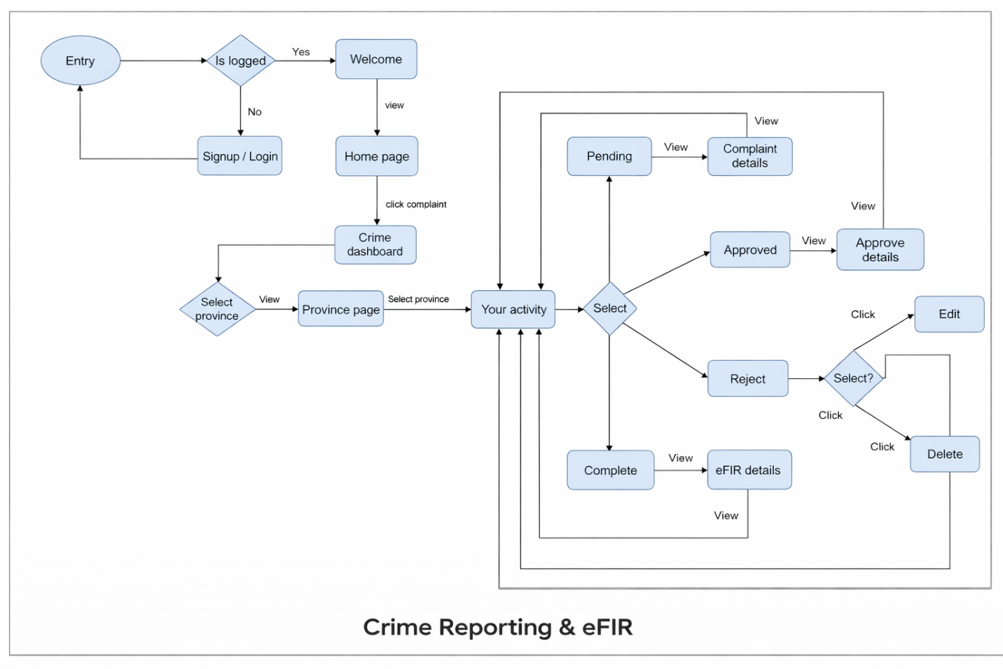

External Interface Requirements
- Web Browser: Any modern web browser (Chrome, Firefox, Edge) serves as the client interface.
- Email/SMS Gateway: Used to notify citizens of FIR status updates.
- Database Server: MySQL RDBMS for storing all records.
- Web Server: Apache HTTP Server to serve the application.

System Design
- Registration and Login Module for all user roles
- FIR Filing Form with multiple data fields
- Admin Panel for FIR management and officer assignment
- Officer Dashboard for case management and status updates
- Reporting and Analytics module for crime trend analysis

User Interface Design
The UI is designed to be clean, intuitive, and mobile-friendly using Bootstrap. Key interface screens include:
- Home/Landing Page with options to register, login, or learn more
- Citizen Dashboard to file and track FIRs
- Admin Dashboard to manage all FIRs, assign officers, and view reports
- Officer Dashboard to view assigned cases and update status

CHAPTER 5
TECHNICAL SPECIFICATIONS

5.1 TECHNOLOGIES USED IN THE PROJECT
5.1.1 NODE.JS WITH EXPRESS FRAMEWORK
Node.js is a JavaScript runtime built on Chrome's V8 engine, designed to automate the deployment, scaling, and management of server-side applications. It eliminates the need to manually configure HTTP servers, routing, and middleware, handling tasks such as load balancing, request parsing, and automatic restarts.

Node.js is deeply integrated with the JavaScript ecosystem through npm packages such as Mongoose for MongoDB, Passport.js for authentication, and Nodemailer for email notifications. It supports multi-node execution through clustering, making it an ideal choice for running high-concurrency backend services. Node.js simplifies backend development by allowing users to create RESTful APIs using eksctl-equivalent tooling in the web space — the Express CLI.
5.1.2 REACT.JS
React.js is a JavaScript library for building user interfaces. It enables the development of interactive, component-based web UIs. React allows each component to manage its own state, making it easy to build complex dashboards from small, reusable UI pieces.

React integrates with REST APIs through Axios, enabling real-time data fetching and UI updates. It supports responsive design and is easily styled with CSS frameworks like Tailwind or Material UI. React Router handles page navigation within the Citizen Portal and Officer Dashboard.
5.1.3 MONGODB
MongoDB is an open-source NoSQL document database that automates the storage, retrieval, and management of complaint records, FIR documents, and user profiles. It enables applications to efficiently handle unstructured and semi-structured data across multiple environments.

MongoDB enables data to be stored as flexible JSON-like documents, making it easily queryable for diverse data types. Key components: Collections (the smallest storage units that hold complaint documents), Deployments (Replica Sets for high availability), Services (Indexes for efficient querying), Aggregation Pipelines (for generating reports and dashboards).
5.1.4 JWT AUTHENTICATION
JSON Web Token (JWT) authentication provides stateless, token-based security for the application. JWT tokens contain encoded user information and are validated on each protected API request, eliminating the need for server-side session storage.

Key security configurations include: Token generation on successful login, middleware validation for protected routes, role claims embedded in the token payload for RBAC, and token refresh mechanisms to maintain secure sessions.
5.1.5 NOTIFICATION SERVICES
Notification services are a crucial part of this project to ensure real-time awareness. Two primary tools are used:

Nodemailer (Email): Sends automated complaint acknowledgement emails, FIR generation confirmations, status update notifications, and case closure alerts.

Twilio / MSG91 (SMS): Sends SMS alerts for critical case status changes, ensuring citizens and officers receive time-sensitive notifications without requiring portal access.

5.2 CODING FILES

Sample Code
Sample PHP code for FIR submission:

Admin dashboard

<?php
require_once '../includes/config.php';
$page_title = 'Dashboard';
$base_url = '../';

$total_criminals = mysqli_fetch_row(mysqli_query($con,"SELECT COUNT(*) FROM tbl_criminal"))[0];
$total_police = mysqli_fetch_row(mysqli_query($con,"SELECT COUNT(*) FROM tbl_police"))[0];
$total_category = mysqli_fetch_row(mysqli_query($con,"SELECT COUNT(*) FROM tbl_crimecategory"))[0];
$total_stations = mysqli_fetch_row(mysqli_query($con,"SELECT COUNT(*) FROM tbl_policestation"))[0];
$total_fir = mysqli_fetch_row(mysqli_query($con,"SELECT COUNT(*) FROM tbl_fir"))[0];

// Fetch latest 3 news for widget
$latest_news = mysqli_query($con, "SELECT * FROM news WHERE is_active=1 ORDER BY created_at DESC LIMIT 3");

include '../includes/admin-header.php';
?>

<!-- ===== STAT CARDS ===== -->
<div class="dash-grid">
<div class="card" style="margin-bottom:0;">
<div class="stat-card">
<div class="stat-icon teal"><i class="fas fa-users"></i></div>
<div class="stat-info">
<p>Total Criminals</p>
<h3><?php echo $total_criminals; ?></h3>
</div>
</div>
<a href="view-criminals.php" class="stat-link">(view all)</a>
</div>

<div class="card" style="margin-bottom:0;">
<div class="stat-card">
<div class="stat-icon red"><i class="fas fa-user-shield"></i></div>
<div class="stat-info">
<p>Total Police</p>
<h3><?php echo $total_police; ?></h3>
</div>
</div>
<a href="manage-police.php" class="stat-link">(View All)</a>
</div>

<div class="card" style="margin-bottom:0;">
<div class="stat-card">
<div class="stat-icon green"><i class="fas fa-file-alt"></i></div>
<div class="stat-info">
<p>Total Crime Categories</p>
<h3><?php echo $total_category; ?></h3>
</div>
</div>
<a href="manage-crime-categories.php" class="stat-link">(View All)</a>
</div>

<div class="card" style="margin-bottom:0;">
<div class="stat-card">
<div class="stat-icon purple"><i class="fas fa-building"></i></div>
<div class="stat-info">
<p>Total Police Stations</p>
<h3><?php echo $total_stations; ?></h3>
</div>
</div>
<a href="manage-police-stations.php" class="stat-link">(view all)</a>
</div>
</div>

<div style="margin-top:20px;">
<div class="card" style="max-width:400px;">
<div class="stat-card">
<div class="stat-icon purple"><i class="fas fa-file-alt"></i></div>
<div class="stat-info">
<p>Total FIRS</p>
<h3><?php echo $total_fir; ?></h3>
</div>
</div>
<a href="view-fir.php" class="stat-link">(View All)</a>
</div>
</div>

<!-- ===== DAILY NEWS WIDGET ===== -->
<style>
.news-widget {
background: #fff;
border-radius: 8px;
padding: 20px 24px;
box-shadow: 0 2px 8px rgba(0,0,0,0.07);
margin-top: 24px;
}
.news-widget-header {
display: flex;
justify-content: space-between;
align-items: center;
border-bottom: 2px solid #f0f0f0;
padding-bottom: 12px;
margin-bottom: 14px;
}
.news-widget-header h3 {
margin: 0;
font-size: 15px;
color: #1a2942;
font-weight: 700;
}
.news-widget-header a {
font-size: 12px;
color: #007bff;
text-decoration: none;
}
.news-widget-header a:hover { text-decoration: underline; }
.nw-item {
display: flex;
gap: 12px;
padding: 10px 0;
border-bottom: 1px solid #f4f4f4;
align-items: flex-start;
}
.nw-item:last-child { border: none; padding-bottom: 0; }
.nw-dot {
width: 10px; height: 10px;
border-radius: 50%;
background: #007bff;
margin-top: 4px;
flex-shrink: 0;
}
.nw-dot.crime { background: #dc3545; }
.nw-dot.missing { background: #fd7e14; }
.nw-dot.notice { background: #28a745; }
.nw-dot.update { background: #6f42c1; }
.nw-title {
font-size: 13px;
font-weight: 600;
color: #222;
margin-bottom: 3px;
line-height: 1.4;
}
.nw-meta { font-size: 11px; color: #999; }
.nw-badge {
display: inline-block;
padding: 1px 8px;
border-radius: 20px;
font-size: 10px;
font-weight: 700;
margin-right: 5px;
}
.nb-general { background:#e3f2fd; color:#1565c0; }
.nb-crime { background:#fce4ec; color:#b71c1c; }
.nb-missing { background:#fff3e0; color:#e65100; }
.nb-notice { background:#e8f5e9; color:#2e7d32; }
.nb-update { background:#ede7f6; color:#4527a0; }
.nw-empty { color: #aaa; font-size: 13px; text-align: center; padding: 16px 0; }
.nw-actions { display:flex; gap:8px; margin-top:4px; }
.nw-actions a {
font-size: 11px;
color: #007bff;
text-decoration: none;
padding: 2px 8px;
border-radius: 4px;
background: #e8f4fd;
}
.nw-actions a:hover { background: #007bff; color: #fff; }
.nw-actions a.del { background:#fde8e8; color:#dc3545; }
.nw-actions a.del:hover { background:#dc3545; color:#fff; }
</style>

<div class="news-widget">
<div class="news-widget-header">
<h3>📰 Daily News</h3>
<div style="display:flex;gap:12px;align-items:center;">
<a href="add_news.php">+ Post News</a>
<a href="manage_news.php">Manage All →</a>
</div>
</div>

<?php if (mysqli_num_rows($latest_news) === 0): ?>
<p class="nw-empty">No news posted yet. <a href="add_news.php">Post your first news</a>.</p>
<?php else: ?>
<?php while ($nrow = mysqli_fetch_assoc($latest_news)):
$cat_cls = match($nrow['category']) {
'Crime Alert' => 'crime',
'Missing Person' => 'missing',
'Notice' => 'notice',
'Update' => 'update',
default => 'general'
};
?>
<div class="nw-item">
<div class="nw-dot <?= $cat_cls ?>"></div>
<div style="flex:1;">
<div class="nw-title">
<span class="nw-badge nb-<?= $cat_cls ?>"><?= $nrow['category'] ?></span>
<?= htmlspecialchars($nrow['title']) ?>
</div>
<div class="nw-meta">
By <?= htmlspecialchars($nrow['posted_by_name']) ?>
&bull; <?= date('d M Y', strtotime($nrow['created_at'])) ?>
&bull; <?= $nrow['is_active'] ? '<span style="color:green;">Active</span>' : '<span style="color:red;">Hidden</span>' ?>
</div>
<div class="nw-actions">
<a href="edit_news.php?id=<?= $nrow['id'] ?>">✏ Edit</a>
<a href="manage_news.php?delete=<?= $nrow['id'] ?>" class="del"
onclick="return confirm('Delete this news?')">🗑 Delete</a>
</div>
</div>
</div>
<?php endwhile; ?>
<?php endif; ?>
</div>

<?php include '../includes/admin-footer.php'; ?>

User dashboard

<?php
require_once '../includes/config.php';
$page_title = 'Dashboard';
$base_url = '../';
$uid = $_SESSION['userid'];

$total_fir = mysqli_fetch_row(mysqli_query($con, "SELECT COUNT(*) FROM tbl_fir WHERE UserID=$uid"))[0];
$pending_fir = mysqli_fetch_row(mysqli_query($con, "SELECT COUNT(*) FROM tbl_fir WHERE UserID=$uid AND FIRStatus='Pending'"))[0];
$solved_fir = mysqli_fetch_row(mysqli_query($con, "SELECT COUNT(*) FROM tbl_fir WHERE UserID=$uid AND FIRStatus='Solved'"))[0];

// Fetch latest 3 news for dashboard widget
$latest_news = mysqli_query($con, "SELECT * FROM news WHERE is_active=1 ORDER BY created_at DESC LIMIT 3");

include '../includes/user-header.php';
?>

<!-- ===== STAT CARDS ===== -->
<div style="display:grid;grid-template-columns:1fr 1fr;gap:20px;">
<div class="card" style="margin-bottom:0;">
<div class="stat-card">
<div class="stat-icon fir"><i class="fas fa-file-alt"></i></div>
<div class="stat-info">
<p>Total FIRs Filed</p>
<h3><?php echo $total_fir; ?></h3>
</div>
</div>
<a href="fir-history.php" class="stat-link">(View All)</a>
</div>

<div class="card" style="margin-bottom:0;">
<div class="stat-card">
<div class="stat-icon history"><i class="fas fa-clock"></i></div>
<div class="stat-info">
<p>Pending FIRs</p>
<h3><?php echo $pending_fir; ?></h3>
</div>
</div>
<a href="fir-history.php" class="stat-link">(View All)</a>
</div>

<div class="card" style="margin-bottom:0;">
<div class="stat-card">
<div class="stat-icon" style="background:#4CAF50;"><i class="fas fa-check-circle"></i></div>
<div class="stat-info">
<p>Solved FIRs</p>
<h3><?php echo $solved_fir; ?></h3>
</div>
</div>
<a href="fir-history.php" class="stat-link">(View All)</a>
</div>

<div class="card" style="margin-bottom:0;">
<div class="stat-card">
<div class="stat-icon cs"><i class="fas fa-file-invoice"></i></div>
<div class="stat-info">
<p>File New FIR</p>
<h3><span style="font-size:14px;font-weight:400;">Click to file</span></h3>
</div>
</div>
<a href="fir-form.php" class="stat-link">(File FIR)</a>
</div>
</div>

<!-- ===== DAILY NEWS WIDGET ===== -->
<style>
.news-widget {
background: #fff;
border-radius: 8px;
padding: 20px 24px;
box-shadow: 0 2px 8px rgba(0,0,0,0.07);
margin-top: 24px;
}
.news-widget-header {
display: flex;
justify-content: space-between;
align-items: center;
border-bottom: 2px solid #f0f0f0;
padding-bottom: 12px;
margin-bottom: 14px;
}
.news-widget-header h3 {
margin: 0;
font-size: 15px;
color: #1a2942;
font-weight: 700;
}
.news-widget-header a {
font-size: 12px;
color: #007bff;
text-decoration: none;
}
.news-widget-header a:hover { text-decoration: underline; }
.nw-item {
display: flex;
gap: 12px;
padding: 10px 0;
border-bottom: 1px solid #f4f4f4;
align-items: flex-start;
}
.nw-item:last-child { border: none; padding-bottom: 0; }
.nw-dot {
width: 10px;
height: 10px;
border-radius: 50%;
background: #007bff;
margin-top: 4px;
flex-shrink: 0;
}
.nw-dot.crime { background: #dc3545; }
.nw-dot.missing { background: #fd7e14; }
.nw-dot.notice { background: #28a745; }
.nw-dot.update { background: #6f42c1; }
.nw-title {
font-size: 13px;
font-weight: 600;
color: #222;
margin-bottom: 2px;
line-height: 1.4;
}
.nw-meta { font-size: 11px; color: #999; }
.nw-badge {
display: inline-block;
padding: 1px 8px;
border-radius: 20px;
font-size: 10px;
font-weight: 700;
margin-right: 5px;
}
.nb-general { background:#e3f2fd; color:#1565c0; }
.nb-crime { background:#fce4ec; color:#b71c1c; }
.nb-missing { background:#fff3e0; color:#e65100; }
.nb-notice { background:#e8f5e9; color:#2e7d32; }
.nb-update { background:#ede7f6; color:#4527a0; }
.nw-empty { color: #aaa; font-size: 13px; text-align: center; padding: 16px 0; }
</style>

<div class="news-widget">
<div class="news-widget-header">
<h3>📰 Daily News</h3>
<a href="all_news.php">View All →</a>
</div>

<?php if (mysqli_num_rows($latest_news) === 0): ?>
<p class="nw-empty">No news available at the moment.</p>
<?php else: ?>
<?php while ($nrow = mysqli_fetch_assoc($latest_news)):
$cat_cls = match($nrow['category']) {
'Crime Alert' => 'crime',
'Missing Person' => 'missing',
'Notice' => 'notice',
'Update' => 'update',
default => 'general'
};
?>
<div class="nw-item">
<div class="nw-dot <?= $cat_cls ?>"></div>
<div>
<div class="nw-title">
<span class="nw-badge nb-<?= $cat_cls ?>"><?= $nrow['category'] ?></span>
<?= htmlspecialchars($nrow['title']) ?>
</div>
<div class="nw-meta">
By <?= htmlspecialchars($nrow['posted_by_name']) ?>
&bull; <?= date('d M Y', strtotime($nrow['created_at'])) ?>
</div>
</div>
</div>
<?php endwhile; ?>
<?php endif; ?>
</div>

<?php include '../includes/user-footer.php'; ?>

CHAPTER 6
SOFTWARE TESTING

6.1 INTRODUCTION
Testing is a process used to uncover errors and ensure that defined input will produce actual results that agree with the required results. A strategy for software testing integrates software test case design methods into a well-planned series of steps that result in the successful construction of software.

The strategy for our project is as follows:
- Testing will begin at the component level and will work outward towards the integration of the entire system.
- Appropriate testing techniques will be used at different points in time.
- Debugging is an activity that will go hand in hand with testing.

6.2 TEST CASES
1. CITIZEN AUTHENTICATION & COMPLAINT SESSION MANAGEMENT
SR.NO. | STEP DESCRIPTION | EXPECTED RESULTS
1 | Citizen Registration & Authentication | Verify that a citizen can successfully register and log in using valid credentials.
2 | Invalid Login Attempt | Check if the system prevents access with incorrect credentials and displays an error message.
3 | Submit a New Complaint | Ensure that selecting 'New Complaint' initializes a complaint session and stores the record in the database.
4 | Save Complaint Progress | Validate that complaint data is saved when the user clicks 'Save Draft' before final submission.

2. COMPLAINT MECHANICS & OFFICER INTERACTIONS
SR.NO. | STEP DESCRIPTION | EXPECTED RESULTS
1 | Submit a Complaint | Verify that a citizen can submit a complaint and the system assigns a unique reference number.
2 | Retrieve Case Status | Ensure that the status dashboard displays correct complaint status and assigned officer information.
3 | Check FIR Generation | Validate that the system correctly generates an FIR when the officer approves the complaint.
4 | Check Case Closure | Verify that the system correctly marks a case as closed and notifies the citizen when no further action is required.

3. BACKEND & INFRASTRUCTURE TESTING
SR.NO. | STEP DESCRIPTION | EXPECTED RESULTS
1 | Database Connection | Ensure that the application can connect to MongoDB and perform read/write operations without errors.
2 | Complaint Status Storage | Verify that every status update made by the officer is correctly logged in the database with a timestamp.
3 | API Rate Limiting & Load Handling | Check that the backend handles high volumes of concurrent complaint submissions without performance degradation.
4 | JWT Token Validation | Validate that protected API routes reject requests with expired or invalid JWT tokens and return a 401 error.

CHAPTER 7
RESULTS (SNAPSHOTS OF RESULTS)

Screen Shots
The following screens are part of the Crime Reporting and E-FIR System:

Home Page:
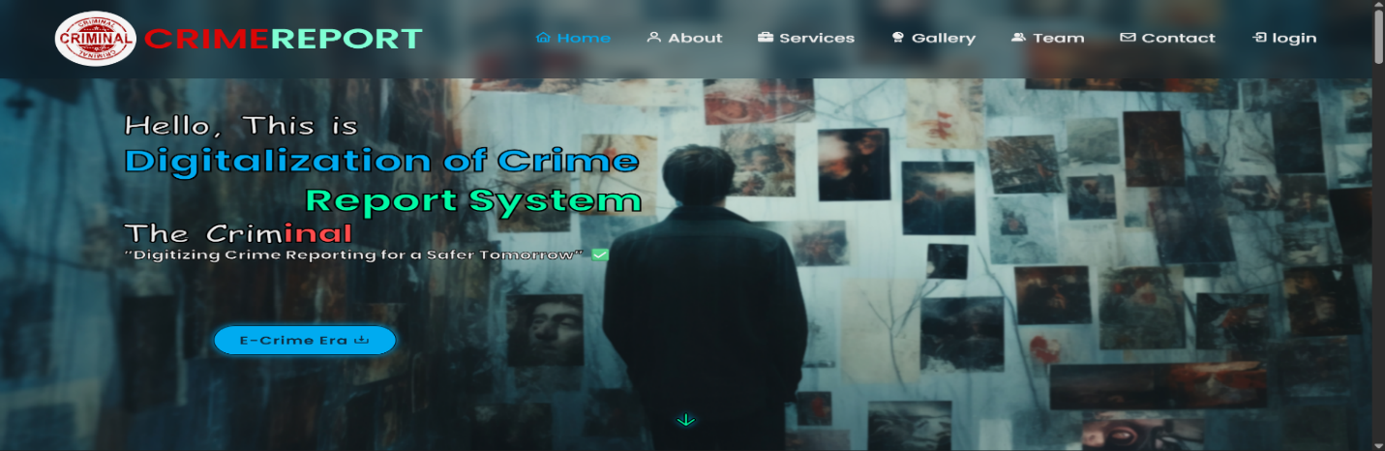
[Screenshot: Landing page with navigation bar, login/register buttons, and a banner describing the E-FIR portal.]

User Registration:
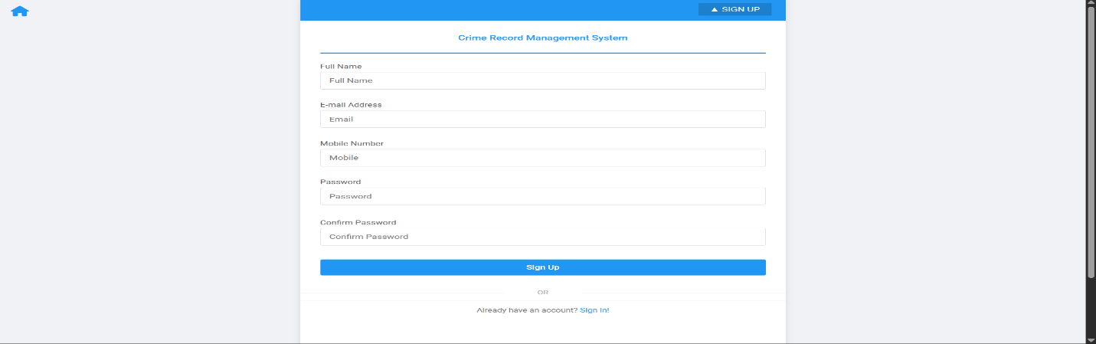
[Screenshot: Registration form collecting name, email, phone, password, and user type.]
Citizen Dashboard:
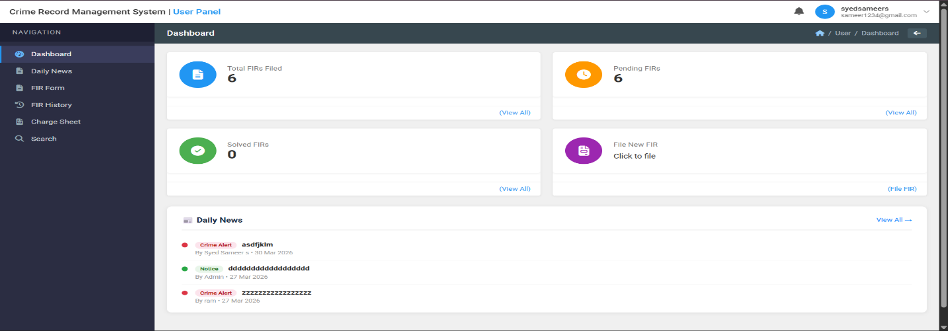
[Screenshot: Dashboard showing filed FIRs, their status, and option to file a new FIR.]

File FIR Form:
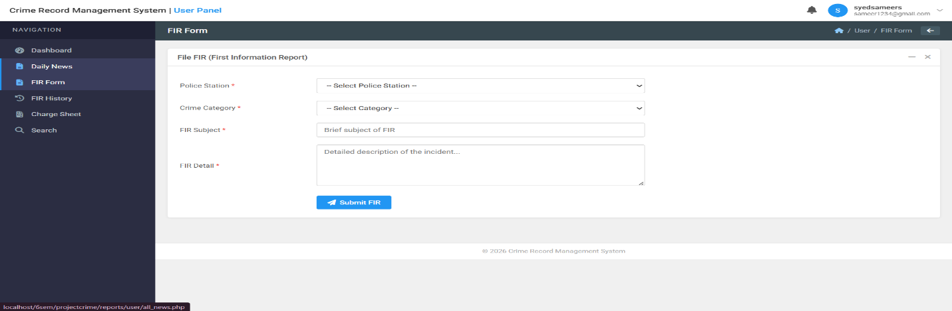
[Screenshot: FIR filing form with fields for crime type, incident date, location, description, and suspect details.]

Admin Dashboard:
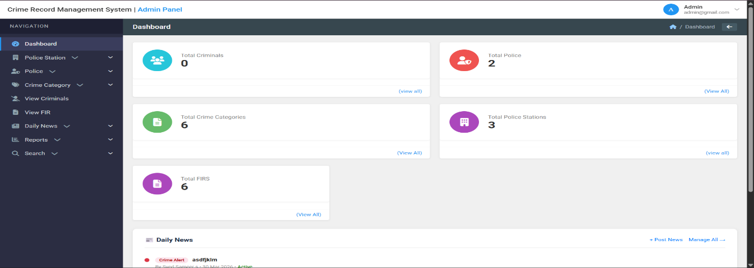
[Screenshot: Admin panel listing all submitted FIRs with options to assign officers and update status.]

Officer Dashboard:
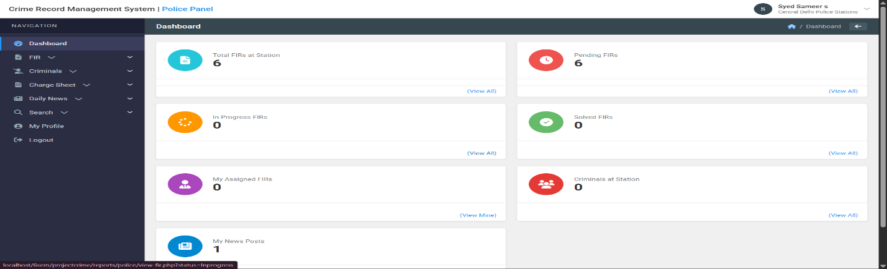
[Screenshot: Officer view showing assigned FIRs and case update options.]

FIR Status Tracking:
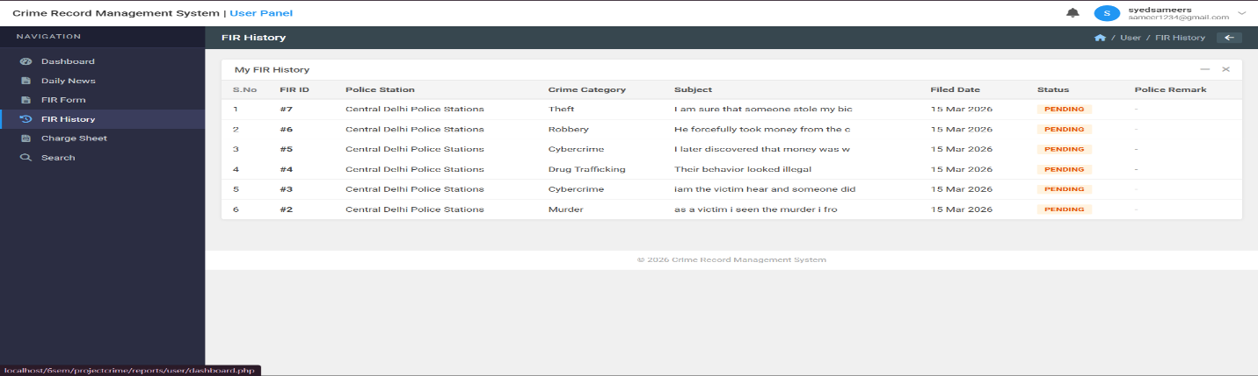
[Screenshot: Citizens can view real-time status: Pending / Under Investigation / Resolved / Closed.]

Manage Police Stations:
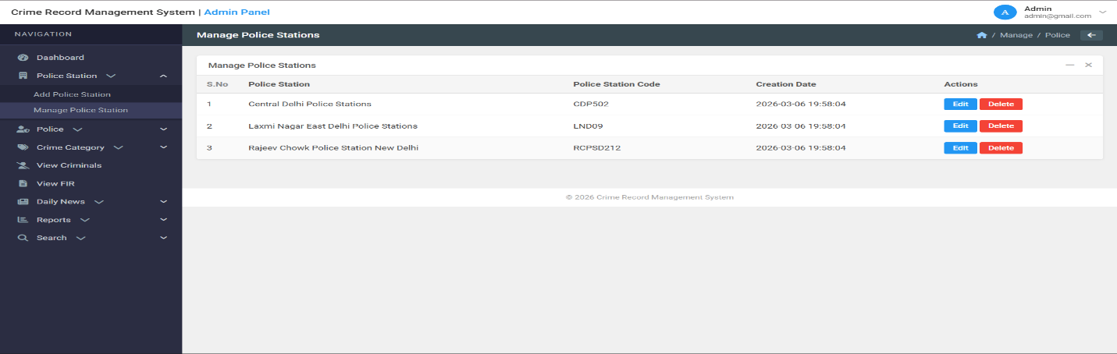
[Screenshot: Admin interface to add, edit, and manage police stations and their jurisdictions.]

Issued FIR Reports:
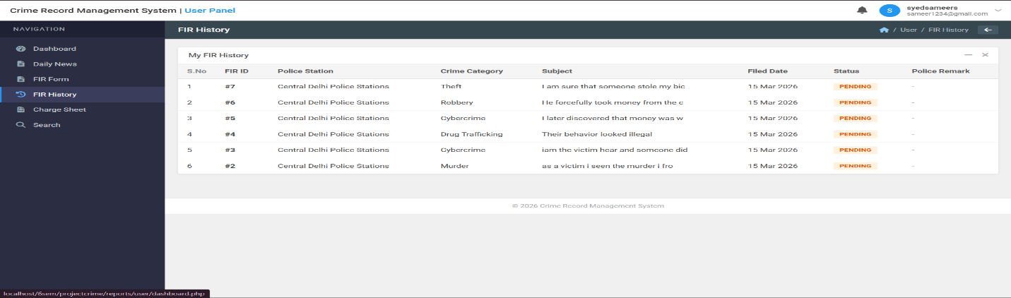
[Screenshot: Admin report view showing all issued FIRs with filter options by date, crime type, and status.
Profile:
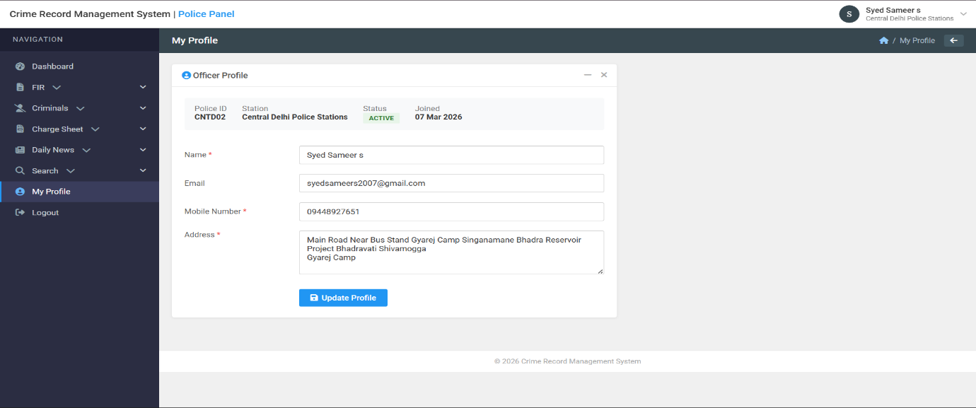

Change password:
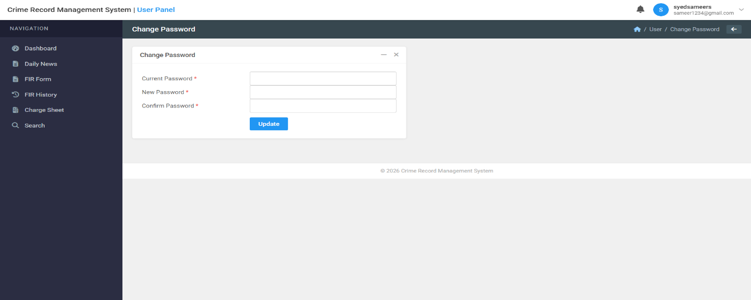

Filter:
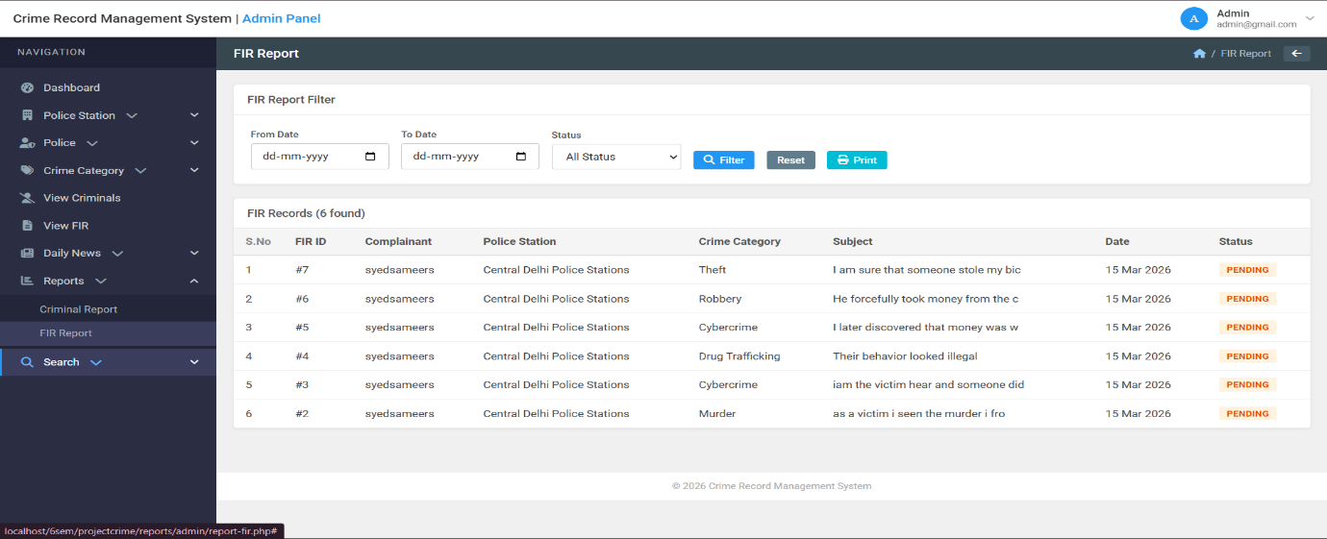

CONCLUSION AND FUTURE SCOPE

CONCLUSION
In an ideal scenario, managing a digital crime reporting system would be seamless, requiring minimal intervention for complaint registration, FIR generation, and case management. However, in reality, handling large volumes of complaints, assigning cases to appropriate officers, and maintaining data security presents numerous challenges. This project has demonstrated that by leveraging modern web technologies like Node.js, React.js, and MongoDB along with JWT authentication, it is possible to automate complaint processing, optimize case routing, and enhance data security while ensuring high availability and fault tolerance.

Through this project, we have successfully implemented a cloud-native complaint management application, showcasing how Ingress-equivalent role-based access control streamlines user management, automated FIR generation reduces officer workload, and real-time tracking mechanisms maintain transparency for citizens. The integration of audit logging and notification services further strengthens system observability, making it easier to track performance and troubleshoot issues. The approach presented here not only simplifies crime reporting management but also provides an efficient strategy for scaling and securing digital law enforcement platforms.

Despite the optimizations achieved in this project, there are still opportunities to improve system efficiency and security further. With ongoing advancements in web security, AI-driven case analysis, and mobile application development, future implementations can enhance the system's resilience, reduce operational costs, and improve overall citizen satisfaction.

FUTURE SCOPE
Technology is continuously evolving, and digital law enforcement platforms are rapidly advancing. While this project provides a solid foundation for a Crime Reporting and e-FIR Management System, there are several areas where further improvements and enhancements can be made:
AI-Powered Crime Pattern Analysis
Implementing predictive analytics using AI/ML models to anticipate crime hotspots before they occur.
Integrating KEDA (Kubernetes Event-Driven Autoscaler equivalent) to scale complaint processing services based on event-driven metrics beyond just CPU and memory.
Enhanced Security and Compliance
Implementing service mesh technologies for enforcing fine-grained security policies for inter-service communication within the application.
Enabling end-to-end encryption and private networking to isolate case data from public internet access.
Mobile Application and Multi-Platform Deployment
Expanding the crime reporting platform to mobile apps (iOS and Android) to improve accessibility and redundancy across platforms.
Integrating on-premises solutions using hybrid cloud models for jurisdictions requiring a mix of cloud and local infrastructure.
Improved Observability and AI-Driven Monitoring
Implementing machine learning models for anomaly detection in application logs and access patterns.
Expanding monitoring with Grafana dashboards for enhanced real-time visualization of complaint processing performance.

REFERENCES

- Node.js Documentation - Node.js Official Documentation. Retrieved from https://nodejs.org/en/docs/
- Express.js Documentation - Express Framework Official Guide. Retrieved from https://expressjs.com/
- MongoDB Documentation - MongoDB Official Documentation. Retrieved from https://www.mongodb.com/docs/
- React.js Documentation - React Official Documentation. Retrieved from https://react.dev/
- JWT Authentication - JSON Web Tokens Introduction. Retrieved from https://jwt.io/introduction/
- e-FIR System Architecture - National Crime Records Bureau (NCRB) Digital FIR Guidelines. Retrieved from https://ncrb.gov.in/
- RESTful API Design - Best Practices for REST API Development. Retrieved from https://restfulapi.net/
- Mongoose ORM - Mongoose Official Documentation. Retrieved from https://mongoosejs.com/docs/
- Nodemailer Documentation - Email Sending with Node.js. Retrieved from https://nodemailer.com/about/
- Twilio SMS API - SMS Notification Integration Guide. Retrieved from https://www.twilio.com/docs/sms

